Job Title | Welfare Officer
Team | WeDiscover
Reporting To Job Title | WeDiscover Skipper, WeDiscover Community Maker
Date of Issue | 10/05/2023

Overall Purpose
In any other setting this role would be called a ‘Welfare Officer’, but our WeMindTheGap ethos means that we much prefer the title First Mate. The role is to be just that: a First Mate is there to make sure that our young people can make the most of every opportunity presented to them over a 12-week programme and further.

You will facilitate learning through a predominantly virtual programme, by grabbing the attention of young people, developing memorable and engaging sessions. You will mentor young people in a one-to-one setting, providing a safe space to express their hopes and dreams. You will also facilitate in-person days for young people to engage in activities in their local community.

You will live by the values of our Magic C’s:
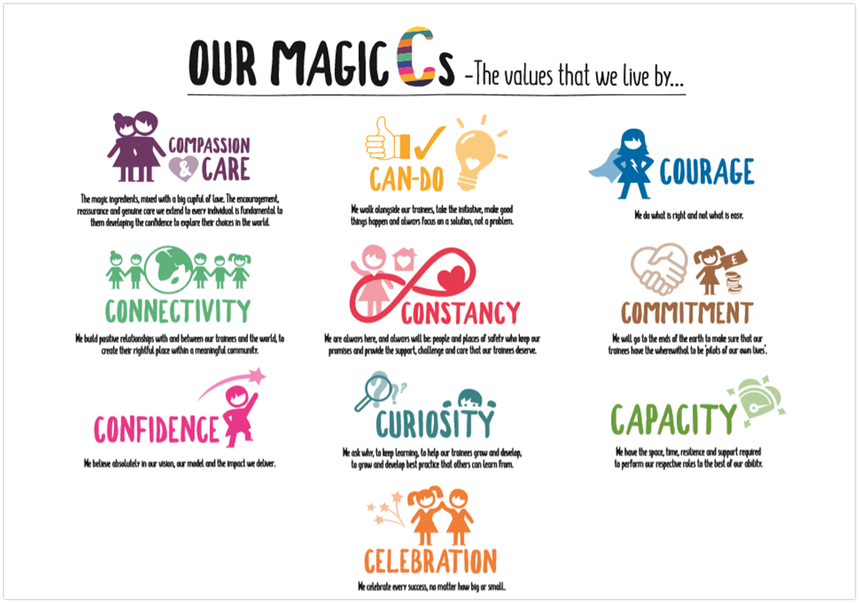
Key Responsibilities as facilitator:
- You will facilitate learning through interactive group sessions, developing the knowledge and skills of young people in an informal educational setting.
- You will encourage curiosity in learning, incorporating digital technology where possible.
- You will host interactive live sessions with a guest speaker or workshop facilitator.
- You will provide a safe learning space, encouraging participation, discussion and debate.
- You will represent WeDiscover and WeMindTheGap when attending local events and connecting with external partners.
- You will Plan – Do – Review in your own practice and role model this process to others.
- You will facilitate in-person days, supporting with organisation, transportation, and implementation, adhering to all risk assessments provided by the Skipper or Community Maker.
- You will prioritise safeguarding procedures, documenting and escalating when necessary.
- You will provide energy and create a space to have fun.
Key Responsibilities as a mentor:
- Compassion & Care – Listen, build trust and be patient.
- Can do – Encourage young people to engage with the programme, to problem solve and overcome barriers to engagement effectively.
- Capacity – Make the time to create a safe space for young people to feel understood and supported in a one-to-one setting.
- Curiosity – Find out young people’s hobbies, passions, hopes and dreams.
- Courage – Exploring barriers to engagement, have challenging conversations and doing what’s right by each individual.
- Confidence – In the power of mentoring, the impact it has, always remembering the ‘why’.
- Commitment – Showing dedication to improving a young person’s choices in life, exploring opportunities, and empowering them to make decisions.
- Constancy – Do what you say you’re going to do, persist with young people when they are showing signs of disengagement.
- Connectivity - Collaborate with a young person and relevant local services in creating a progression plan.
- Celebration - Recognise and celebrate every win, big or small!

Other responsibilities:
- Administration – Recording and monitoring attendance and contact with young people and their support network. Keeping all relevant systems accurate and up to date. Monitoring and managing your diary and emails.
- Communication and Feedback – Linking with referral partners, feeding back progress, and connecting young people with relevant progression routes.
- Social Media – Supporting with the creation and publishing of social media content on relevant channels.
- Recruitment – Playing a key role in a rolling recruitment cycle, reaching out to potential participants, and attending local events.
- WeBelong – Supporting WeBelong, WeMindTheGap’s ever growing alumni community. This includes facilitating events and activity days, delivering group workshops and one-to-one support, and maintaining contact with young people who have engaged with any WeMindTheGap programme.
- Flexibility – Supporting other WeMindTheGap programmes and teams in locations across North Wales.
Competences
- Great communication and listening skills, as well as the confidence to raise any issues with your colleagues as appropriate.
- A sense of humour, the ability to have fun that is balanced with an ability to call the young person to account when the need arises.
- A willingness to learn best practice in how to support young people with complex needs and embrace the mentoring and supportive techniques which drive the programme.
- You will uphold and communicate the values and culture of WeMindTheGap.
- You will have a real passion to enable young people to enhance the choices in their life.
- During the programme you will have to be adaptable and remain calm under pressure.
- Teamwork is a key competence, sharing experience and knowledge with the whole team.
Person Criteria
- Experience as a mentor or voluntary role with young people with challenging needs would be advantageous, as would experience of working with young people with various educational and social needs, but not necessary.
- Ability to think smart, have active listening skills and build relationships.
- Be flexible due to the very nature of the role, and the support that you will be giving to the people, means that you will need to be flexible in your approach and time management.
- Agree who will be point of contact during out of hours on a rota with the Lead.
- Work collaboratively together as a team with support from our central office, our ‘Hub’.
- Lean on the WeDiscover Lead or Community Maker for advice, as a sounding board with regards to any safeguarding issues.
- At all times, maintain all information relating to the young people and the model responsibilities in strictest confidence.
- Welsh speaker desirable.
- Driving License Essential.
- Travel to Wrexham Hub at least once a week essential.
Measures of Success
- Confidence in the WeMindTheGap WeDiscover model.
- All relevant systems are kept up to date, documentation is shared in Sharepoint/Workplace and CPOMS.
- Regular workplace updates, celebrating every small win and providing information about the wider community.
- Building trust and rapport with the young adults – being the trusted ear.
- Being curious about the young people’s lives, showing passion in supporting them to make steps towards the future that they deserve.
- Walk alongside each young person throughout the programme, empowering them to find their voice, to change behaviours and to gain news skills to enable them to make better choices.
The above list of job duties is not exclusive or exhaustive and the post holder will be required to undertake such tasks as may reasonably be expected within the scope of the role. Job descriptions should be reviewed regularly (6 weekly review) to ensure they are an accurate representation of the post.

